BPCC 2020 Match Reports

BPCC vs The Cricketer’s Club CC – 26th July 2020
/ Match Report / By ade
So to our annual fixture against the rather eccentric and non aggressive blazered “Cricketers Club”XI featuring the talisman Pete Langman.
BPCC chose to bat and captain Phil Boardman got a beauty that came in and just clipped the off stump 3rd ball . Keyes joined Simon Parker, his first scoring shot a six straight over the opening bowlers head! The partnership flourished until Keyes was adjudged LBW (P.Spearman) for a well made 46, he chuntered all the way back to the “pavilion” indicating it was either going over the top, down leg, or he was too far down the track to be possibly given out, Phil Spearman when he finished he spell of umpiring ended the debate “look in the book Keysey, LBW”. Luckily Villa had scored a goal by then and he didn’t rise to the bait. Stalwart David Hughes slowly made his way to the wicket a few well taken singles made him look solid at the crease until called upon to “run “ a single a direct hit saw him back on the benches.
Nick Bartlett strode to the wicket with more purpose than Wednesday night (0 ) and was soon punishing the bowlers with some lusty blows.
Parker was soon out (“probably the slowest 11 he has scored “his words) to super catch from Sam Baker Jake Spearman(2) looked stylish but didn’t last long to be replaced by Tom Weedon – these two continued the late onslaught until Tom sent Nick (28) back to be sacrificed for a run out
Kerr(1) and Spearman (2) held up the other end while Tom plundered a quickfire 28 with extras featuring heavily (30). Total 152 looked enough.
Boardman introduced an interesting tactic opening with Finn Spearman (yes Spearmans making up 27% of the team) and Stan. The plan worked; in Finn’s first over a maiden and second over he bowled their opener for his debut wicket for Blenheim aged 13!
After 4 overs of spin Weedon came on inspired by his runs and trying to impress his doting parents showed great pace and was rewarded with bowling their other opener.

Champagne Moment

With the Cricketers passing 50 at a gallop their impressive looking Sam Baker smacked a half volley from Weedon towards Simon Parker who stuck out a left hand and caught the ball low down not only saving a certain four but dismissing their best batsman .
Jake S chipped in with a wicket and with Weedon tiring and Jake bowled out it was time for Bartlett and Spearman Senior to show the family he wasn’t ready to let his boys get all the plaudits . His first ball was a half tracker that was sweetly struck straight down the throat of deep mid off Jake Spearman out ! Even though the wickets fell they wer up with the asking rate and passed 100 mark with 10 overs to go. Game on.
Turning Point! With No6 M Funge looking comfortable but running out of partners was forced to up the pace a Rhino special saw him go for the big one over the top , momentarily leaving his crease for a split second , only for the sharp Keeper Kerr to whip the bails off BOOM STUMPED! THE GAME TURNED.
Phil cleaned up the tail and Simon Parker took the last wicket not before Phil Boardman actually fielded the ball in the penultimate over (welcome to the game Phil!) Great game played in good spirit well captained by Phil and excellent performance in the field probably won us the game.
MOM -Finn Spearman
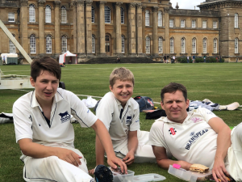
4 fer Phil and the Rhino cubs
Report: Robert Kerr (duh)

Opposition match report:
https://www.pitchero.com/clubs/cricketerscluboflondon/teams/25713/match-centre/0-4782021/report

BPCC vs South Wales Hunts CC
/ Match Report / By ade
“Too Good, Too Young, Too Hot!”

It seems each morning and each day in the past week the temperature had been rising, little did we know it would peak on the sunny Sunday where Blenheim Park CC would host the South Wales Hunts. Everyone arrived at the pitch side to witness what could have been the largest Blenheim boundary in history, Skipper Malcolm West thinking that this large playing area would suit the cricket of the lads.

Malcom went in with the Hunts skipper to do the toss, the thoughts of all 22 players was “please bat first”, Malc loses the toss and Blenheim were sent into almost 30-degree heat to bowl at a young and excited South Wales Hunt. The Hunts got off to a slow start as Blenheim openers Weedon and Angol kept the run rate low, Angol using his Birthday magic to get fantastic figures of 7 overs for 25 runs and an over in hand. 16 overs in and Hunts were only up to 66 runs, Blenheim had a few chances with a dropped catch and some opportunities for run outs as Hunts pushed the singles but all to no avail. It was after the 20th over that the hunts started to push with batsmen Williams and Enslin both pushing to 50, Keyes and Spearmen Senior entered the bowling attack at a difficult time in the game, the heat was definitely starting to take its toll and the Hunts started to pick more gaps in the field and pick up 2s and 3s with only the odd shot hitting the boundary. Keyes short stint saw a few shorter balls than he would have liked, and the Hunts openers were so comfortable at the crease that they ceased any opportunity as they looked to push on. Keyes lasted 4 overs and went for 23 at this point both Batsman had got to their 50 and were looking strong. That was until McCall came into the fray, as in his second over he was able to find the breakthrough for Blenheim. A ball outside the off-stump was swung at aggressively by Williams (63) and edged into the mittens of Rob Kerr who celebrated in typical Kerr fashion running down the side of the square towards his adoring fans and teammates. Blight entered the crease for Hunts and at this stage Enslin was nearing a 100, Skipper Malcom West was becoming a little bit more annoyed with the standards slipper for the hosts, McCall left the attack and on came Bartlett, meanwhile Spearman was bowling from the other end in typical Spearman fashion, he even said to Weedon “this run up I’ve got is making this hard” which is disgraceful as he comes of 5 steps and 4 of them he walks for.

Back to West’s feelings about the fielding, it was the 25-30 over, the heat was killing us the gaps were being exploited boundaries were coming quicker. We were chasing a lot of ball Boardman was melting, Simon was wishing he had factor 50 on, and Malcom was fielding on the boundary. The ball was casually hit to him, he waits for the ball to approach, picks the ball up and in one big action winds up the underarm throw, little did he know he let go of the ball too late and gifted 4 runs to the Hunts and we threw it back over his own shoulder and over the largest boundary in Oxfordshire. This made the fans day, with some calling it a champagne moment. In the 30th over Enslin reached 103 and was retired in the 35th over to give the other lads a bat, incredible innings from him. The last 5 overs saw the hunts try to smash us around the park as they had the freedom of wickets to play with, Bartlett was able to take the wicket of Blight (3), Stan Angol came back on to pick up the wicket of Lodhi (21)with a fantastic caught and bolwed which was smashed back at him. And McCall took Doolittle (15) and with McCalls wicket Hunts declared with 3 balls of the innings left.

Blenheim spent lunch trying to recover from a big effort in the field, only needing 5.5 an over didn’t seem an impossible task, but the lads were tired and feeling the effects of bowling. While Hunts came out buzzing and rattled through their overs with immense speed. Boardman and McCall went out to bat first, the Hunts opened with Saunders and Dell who looked to do a lot with the new ball. It was a really tough 10 overs but neither wicket fell and the openers finished their spell. McCall saw this as an oppertunitiy to have a bit more of a go but little did he know their bowling attack was very strong, the first over of change bowling saw Lodhi bowl 2 no balls and then on the third no ball of the over McCall was caught behind, luckily a no ball was given. McCall (10) didn’t learn from his mistake as he took a swipe at one outside off stump and was then caught behind by star man Enslin. In the next over Boardman who feeling the effects of the sun saw his eyes light up as Mulvhill came on to bowl spin with the 3rd ball Boardman took an alight swing and that was the end of his time at the crease stumped by the best keeper to have graced the Blenheim grounds. Into the crease came Keyes and Parker two of the Blenheim’s best with the bat, it didn’t take long for Keyes to start having a go at the spin bowling starting with a four and getting 2 sixes in a row, which didn’t please Stan as he was rudely awoken to the shouts of “heads” and at the last minute was able to dodge a huge 6 from Keyes. Parker batted sensibly with him and Blenheim were able to reach 70 before a falling wicket. Keyes (30) was caught and with that a definite shift in the game as the next over saw Parker (12) LBW from Lodhi. The Hunts were in full flow and loving the hallow turf of Blenheim with the banter increasing in the field. Inge and West entered the crease and it wasn’t long till Mulvhill was at it again taking Inge for 2 runs while West kept at it in his own fashion of hit everything really hard. Bartlett came into the game and scored a 4 but once again Mulvhill (4) had him stumped. Mulvhill taking 2 wickets in an over spelled a mini collapse for the hosts as their hopes of any sort of win was out of the question. 7 down and only 86 runs to Blenheim’s name.

It became a matter of pride for the hosts, getting to over 100 and seeing what happened from then, after Wests giving away of runs he batted like a man who was looking for redemption from his own players giving every ball all his effort but no one could stay with him, Weedon caught from Mulvhill for 0. Kerr Bolwed for 2 from Doolittle had West thinking no one wanted to stay with him, Spearmen entered at 9 and looked the best of the last 3 batsman to have gone in but could only get 6 before Khot bowled him out. Leaving the one-armed Angol to come in and have a birthday hit, 2 balls later and he hit one into the arms of fielder and that spelled the end of the Blenhiem chase. All out for 113.

Overall a great game but the team that bowled first would always have had a tough time in that heat, the spirit of the game was great and most players were in the Woodstock Arms after the game for food and drink and a Happy Birthday sing for Stan Angol who was 25 this week. A big difference in class at the end of the day but we hope to see the South Wales Hunt back again. Stan bowled superbly and the batsman of the day and overall man of the match taking a superb catch would go to the Hunts Enslin scoring 103.

Broadhalfpenny Brigands vs BPCC – 23rd August 2020
/ Match Report / By ade
Let us never speak of this day again.

BPCC vs Thame – 30th August 2020
/ Match Report / By ade
Shaw tames the oppo!
Initially our batting line up looked a little light. However we had not accounted for Will Shaw. That’s Will Shaw, not to be confused with that County of carrot crunchers to the south west – this was Will Shaw the proud Yorkshireman (like there’s any other type). After a nervy start, more from Shaw Snr (from beyond the boundary) than his younger relative to be fair, the latter got going with a massive 6 (like there’s any other type) which set the tone for the innings. Boardman stuck with him for 10 overs before being given out LBW to Mather. Which seemed fitting as even the opener’s mother would have had to have given it.
Other partners came and went every half a dozen overs or so, but Shaw the Younger kept going. As he plundered, biffed and, on occasion, caressed the ball, usually to the boundary, questions were being asked in some quarters about family lineage. Could they really be related? By the end of our allotted 35 overs the young tyke had amassed an assured and undefeated 102 (six 4’s, six 6’s) out of our total of 160-5. A generous 22 wides were gifted by our benevolent visitors but no-one else managed the lofty heights of even double figures – Skipper West, and Spearman (J) missing that milestone by one a-piece.
With the track deemed treacherous to all from south of the Watford Gap, this seemed an above par score and one which we were Shaw we could defend. And so we did. And although collectively the bowling unit performed well on a helpful wicket, the extent of the victory lay as much with the reluctance of the top order to show any intent whatsoever as to the combined efforts of the 5 bowlers. At 28-3 off 21 it was enough to send even the most ardent of insomniacs into a stupor.
Walker (2-6) & Weedon (0-14) exploited conditions well with the former delivering his trade mark swinging ball pitching on leg and hitting middle. He struck again when Spearman Snr clung on to a swirling steepler of a catch at mid-off facing directly into the sun that had made an all too fleeting appearance on an otherwise ‘two jumper’ day.
It was the same Spearman (2-12) who, as 2nd change, accounted for the opener to dispel (once again) vicious and unfounded rumours than he can only dispense with tail end rabbits. Hitherto that end had been shored up to such an extent that King Cnut himself would have been proud.
Elsewhere in the field, Parker clung on to a sharp chance in one of the silly positions (more so in that it was Stan bowling at the time). Kerr, the keeper was tidy behind the stumps and unusually well-mannered, allowing just the odd bye through whilst also snaffling one off Angol (3-30) himself.
J Spearman (3-14) returned to the attack at the death and suggested that maybe rabbit slaying does indeed run in the family after all, sending 3 back to the hutch as cheap as chips. With 10 men in the field by this stage, and one catch put down he figured he needed to finish the job himself – and so he did bowling two and finishing the innings with a cracking caught & bowled. Thame has subsided to a tame 78 all out in 33.4 overs.
We then experienced the legendary Shaw hospitality with a socially distanced BBQ where we all huddled around the fire to keep warm and make merry. If you liked succulent steak to die for and cooked to order, quality sausages and burgers with marinated salad and gherkin or jalapeno peppers (or both if you were greedy), you were in the right place. And in the dying embers and fading light of this most peculiar of summers we all knew that we were.
Presentations then followed. As is customary at a Blenheim social, Rob Kerr invited himself to make a speech and, before blowing some appropriate smoke, he suggested we could say what we liked about Mr Shaw. Micro seconds passed before 3 members stood up simultaneously to voice their opinion before being quickly drowned out by this years un-elected captain Malcolm West who went on to present the club awards which were as follows;
The Andrew Shaw batting award: Lee Keys
The Nigel Walker bowling award: Raj Gokani and Tom Weedon
The David Hughes fielding award: Jake Spearman
The Stan Angol Clubman award: David Hughes.
Obviously, with the surreal period we are in, these were for the 2019 season. As Bob Dylan, almost once said – The Times They Are Unprecedented.
So, a cracking days cricket and a fine early evening’s BBQ Bonhomie to finish.
Both meat and team selection were spot on and for that we must surely thank our esteemed Chairman.
For Shaw!
Match report: Rhino

Sheepscombe vs BPCC – 6th September 2020
/ Match Report / By ade
Picture the scene. A young family awakes one September Sunday to see the sun shining and quickly the realisation dawns on them that today is to be the day when they all get to play cricket together – for the men’s team – possibly for the first time ever. Excitement, anticipation, anxiety and high hopes all mingle into one with the thought that today they could be their teams hero, in front of extended family members who will be turning out en force to cheer on the young lads and dad together in the glorious setting of the Laurie Lee field, Sheepscombe. Breakfasting together there would be talk of where they would each bat, who would score the most runs and take most wickets. Banter would continue as they cobble together a shared tea to be eaten mid-game whilst reflecting on the highlights of the previous innings.
Yes, that first game where the whole family plays together is a never to be forgotten rite of passage …
We bowled first and West the Skipper-cum-stand-in stand-in keeper quickly captured the zeitgeist, if not always the ball, by performing an almost unprecedented act in these unprecedented times. Yes, Malcolm achieved a seemingly impossible (for BPCC) stumping as the Sheepscombe opener danced down the track early doors to a flighty and far from filthy off-break from Angol (the erstwhile stand-in keeper) and managed to not only stop the ball but break the wicket in a controlled manner to ensure the dismissal was complete and legitimate.
Meanwhile, at the other end Weedon kept it tight bowling 4 maidens in his first spell but was nevertheless un-penetrative at this point.
The Spearmen filled in the dull middle overs with 30 coming off the next 10 overs. It was 2nd change Spearman Snr who accounted for the opener to dispel (once again) vicious and unfounded rumours than he can only dispense with tail end rabbits. Hitherto that end had been shored up to such an extent that King Cnut himself would have been proud. He went on to snaffle a second and celebrated with some quality Dad dancing. Which was quite embarrassing. Apparently.
At 116-3 in 27th over the game was in the balance. Jake returned to the attack and finally found a way past the Sheepscombe no.3’s inside edge that had hindered us all afternoon. Bartlett was by now bowling at the top end with some impressive shape, and two further wickets fell to the tattooed trundler to turn the tide our way.
With Sheepscombe having slumped to 129-6 off 32, there was therefore no requirement for what then followed.
Weedon returned for a second spell from the Valley end and with his second ball broke through the young batsman’s defence for what seemed at that point like a well-deserved, if cheap, wicket.
But It wouldn’t be a Sheepscombe / Blenheim fixture without a no-ball / youngster controversy and so it was again this time around as Weedon then proceeded to bowl a neck high beamer to the even younger new batsman. Visions of 2018’s no-ball-gate flashed across our minds but fortunately the past is a foreign country and they do things differently there. Despite several Blenheim fielders signalling a no-ball the Sheepscombe umpires refused to enforce the law and an unrepentant Weedon followed up this generous gesture by clean bowling the by now fraught youngster next ball. During this passage of play the Blenheim entourage were rapidly scanning the lawbook to ascertain if an appeal could be revoked when the batsman has been clean bowled. But not content with 2 youngsters in 3 balls, Weedon then cleaned up dad too to leave him on a hat-trick against the incoming no.11. Suffice to say, whilst the rest of the team were hiding their embarrassment behind their hands, Weedon completed the over, his hat-trick, and the innings by again finding the stumps with a jaffa.
Awesome, unplayable and phenomenal.
These were all words left unspoken at this particular point in the game. Instead ‘bully’, ‘shameful’, & ‘resign’ are likely still ringing out across the Gloucestershire escarpment as I speak. Never in the long history of cricket has a hat trick been greeted with quite so many groans. This PE teacher who has chosen to make a career out of helping youngsters fulfil their potential through sport, ruthlessly tore the heart and soul out of a cosy Cotswold family unit as if in one of those formulaic Spielberg movies. The hopes of that morning had been abruptly dashed within the space of just a handful of deliveries and unlike Spielberg, there was no attempt towards the back end of the script to make amends as the family left the field – perhaps never to return – devastated at how their day had been ripped apart by the wolf in sheep’s clothing who by day masquerades as a mentor. We all now know his true colours.
Weedon will undoubtedly point to the saying in recreational cricket that it doesn’t say how old the batsmen were in the book. But let me make it very clear; two of these wickets were under 13 years old.
So anyway, after this despicable behaviour, we batted. After an uneventful first few overs we then lost Boardman, Cox and Parker in quick succession having all first found the boundary. At 39-3 after 14 the game was again back in equilibrium.
Vaughan-Fowler then joined West to rebuild the innings but it wouldn’t be a Sheepscombe / Blenheim fixture without a no-ball / youngster/ wicket controversy. Shades of 2018’s no-ball-gate flashed before us as the new bat lofted one straight to mid-off after the ball had pitched twice. But the past is a foreign country … with JVF half way back to the boundary, common sense prevailed and a no-ball was eventually called by the young umpire.
Meanwhile, Malcolm was accumulating rapidly at the other end, and Vaughan-Fowler began hitting hard and true, as you would expect for someone named after not one but two former England openers. As is also true of English openers though, his innings came to a premature end, playing across the line to be bowled for a quickfire 18. The two had however added 54 in a little under 9 overs to get the Blenheim boys back on track.
Bartlett joined his captain and with just handful required, Malcolm – not content with emulating Joss Buttler behind the stumps with the one moment of competence in amongst all the fumbles – felt the need to match his batting too. And so he did, bringing the game to an end with a massive 6 (like there’s any other type) to record his first Blenheim 50 in over 2 years.
David Hughes turned up and we all then retired to the Butchers (well those who could park anyway) where Weedon was made to face the wall and think about the consequences of his recent actions and Malcolm led by example by getting the beers in to celebrate his fine game.
Thanks to Nigel & Allan for agreeing to step down (and in Nigel’s case score) when we were over-subscribed this week.
A fist pump too to the Sheepscombe team for playing the game in the spirit it is meant to be played.
Sheepcombe 130 ao (33 overs)
Blenheim 135-5 (30 overs)
Rhino

Steeple Aston CC vs Blenheim Park CC 13th September 2020
/ Match Report / By ade
Yet again we find ourselves playing at one of the iconic grounds in Oxfordshire . The scene was set for a perfect day’s cricket – Angol/Engel/Spearmans et al what could possibly go wrong ?
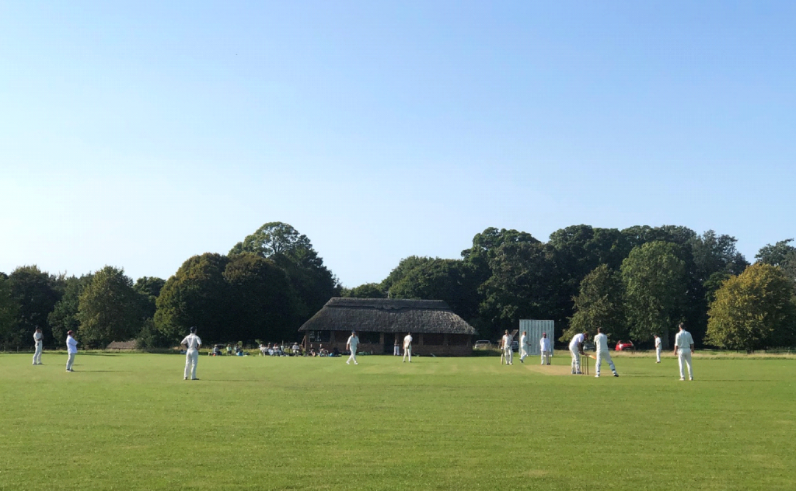
Malcolm won the toss and elected to field , a brave shout as Allan E had yet to appear and Coxy was obviously aillures et tard. Things looked threatening as Steeple Barton sent in their two young guns , but Stan had them bamboozled at one end and Nigel bowled his normal line and length with some beauties beating the bat.
Stan struck first when their opener missed a straight one that hit middle peg Walker had the other opener as he opened his shoulders cracked a drive through the covers only for Simon Parker to catch a “worldy”
Stan’s third over saw the famous Chestnut Tree come into play several times, twice off the bat and the third time from Nigel (4 runs!)
Walker Finished his spell with an impressive with 7/3/17. Recently condemned man Tom Weedon showed plenty of spirit in his bowling !! A rum display that saw the batsmen play a few ‘shots’ – an intoxicating spell 7 overs 4 maidens for a miserly 11 runs. Always a tonic to see him bowling.
Their captain Nigel Doggett (44) put on a good partnership and things started to get away from BPCC but Spearman (P) had his man also caught by Simon in the deep Finn Spearman promoted from scorer to Chairman substitute came on to bowl and acquitted himself very well and unlucky not get a wicket – Johnny Vaughan-Fowler making his 2nd Indian Summer
appearance also unlucky not to get a wicket kept the scoring rate down (5/22) Malcolm eventually turned back to Stan and in a Morganesque bowling change produced a wicket when Kerr ever sharp whipped the bails off for another smart stumping.
The last ball of the innings saw the batsmen attempt a suicidal run with Kerr whipping the glove off picking up pirouetting in one move with one stump to aim at – it was never in doubt … out !
Overall fielding display was a tremendous effort and Barton’s total of 132 looked easily achievable..
Cox and surprisingly promoted Kerr opened the batting – It was soon clear scoring on this wicket with tight bowling was going to be difficult Kerr perished leaving a ball 18inches outside off that turned sharply and hit his off stump.
Parker looked in excellent form striking three boundaries until what looked like his fourth was plucked from the air for what was the second outstanding catch of the match by the opposing skipper so send him back (13) to the pavilion. Skipper West hoping to carry his good form of last
week to this match perished after two balls offering a top edge tame catch .
The eleventh over (yes really!) saw Coxy finally score his first run (C’est incroyable!) . Phil Spearman clearly meant business and struck the ball well until he was caught (15) Johnny V-F scored as many as the Skipper.
Alan Engel (11)showed glimpses of his former glory days hitting two boundaries , there is no doubt how he was out as it is captured on film (middle stump ! ) Angol scored his customary boundary and then perished, Coxy (20) eventually fell and it was left to Weedon and Finn Spearman to keep us with an air of respectability as we limped to 73/9 in the 35th over
Great fielding performance , followed by a disappointing batting display but a wonderful setting and most retired to the White Horse at Duns Tew for a libation .
Match report: Bertie Kerr (obviously)
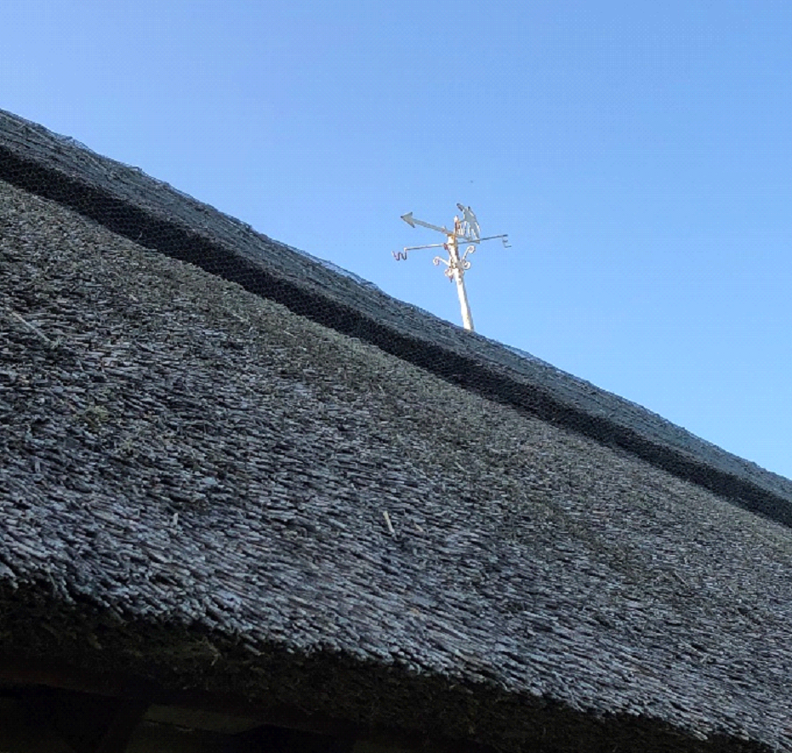
Post navigation

Bampton in the Bush CC vs Blenheim Park CC – 20th September 2020
/ Match Report / By ade
So soon
Too soon
This twisted
Troubled and truncated
Season that nearly never was
First burst brilliantly to life, burning brightly with victory upon victory
Then faltered slow amid inevitable availability woe
Peppered with sanity breaks
Bowling masterclasses
Batting collapses
And now today
Too soon
So soon
It ends
As is traditional the Blenheim captain lost the toss but happily was asked to bowl on a beautiful south Oxfordshire afternoon. Our dynamic opening bowling partnership with a combined age of 130 showed their usual personality traits. Stan’s Caribbean flair, toss it up and have a go but miss and I hit vs Nigel’s “you will score runs over my dead body lad” approach. With cautious batting and no breakthrough in sight and the “I can’t bowl at that end, I might hurt my ankle” left arm quick insisting on bowling after Nigel. Stan gave way to the young cycling turk of the BPCC line up
“Wheels” Spearman.
After a few overs of having his trial outswingers carted around the park he went back to tried and tested inswing to devastating effect. With two in two spanning an over end seeing both openers back in the pavilion trying to drive against the swing and we were looking at another possible away hattrick (and likely a much more deserved one). The incoming no 4 saw the ball take his bat shoulder and loop over the crouching tiger of Stan prowling at square leg but fall safely behind. Wheels made up for it though snaffling his man several overs later to finish the pick of our bowlers with 8 overs 3-27.
With Nigel completing a typically miserly 8 overs for just 11 runs but unable to bag any wickets. It was Toms turn to test out the middle of the wicket, and out turn to chase some leather. When he pitched it up he was unplayable but we discovered when he didn’t these boys could cut and pull well on a true track. Phil “the big 5” Spearman (bowls like Rhino, catches like a crocodile) replaced his son and also took a bit of tap as the Bampton middle order realised they had to get on with it. He did pick up 2 wickets with the usual wily flight and variable pace and a 7-2 legside field which the
batsman insisted on playing to leg…go figure. The returning Stan picked up a couple of wickets and also got some tap as Bampton went up a gear remembering the innings and summer was nearly over. Our recent turn to death bowler JVF was unable to staunch the flow as Bampton accelerated
to 165 which to us looked like a formidable target. (anything over 120 had looked formidable to our batting this season without Lee playing).
As we sat socially kettled on the outfield enjoying some lovely end of season cakes Skipper cycled through many batting line ups before deciding Wheels Speaman should join our ever present opener Phil to lead our reply. And it looked an inspired choice as they took us to 40 in the tenth over before
the first wicket fell. Keeping us up with the rate and baring the brunt of the Fine opening Bampton attack with some great running and some sweetly timed classy driving. Ironically it was a change to weaker bowling which did for both of them with both succumbing to something loopy, eyes alight
they dragged out and two smart stumpings saw us nervously eying the score board again. Simon pushed the score on nicely looking in good touch and then joined by Martin the innings was consolidated. Before Simon was caught bowled, a sharp take by the bowler and out hobbled skipper
West at 5. At 70-3 in the 19th over we were again drifting behind the rate and with just JVF and the tail to come it was time for some heroics.
Knowing there were 8 overs of returning openers to negotiate before the end of the innings West and Cox set about making late summer hay against the friendlier change bowlers. Reaching the boundaries often and mixing this with uncharacteristic quick singles and snaffling of byes. With one
returning opener seen off the other came back and tightened it up with tension clear along the knowledgeable travelling support and the boundaries dried up it was twos and hurried singles that kept the scores ticking along close to the rate but never ahead…40 of 10 then 23 off 5 as Bampton clawed their way back into it. But with 19 required off 4 and a return to change bowling at both ends Coxy cut loose (yes do not adjust your screens you are reading this correctly) carving the bowling up and taking us to a memorable victory and himself to an unbeaten 53. Our third wicket partnership having put on 96 in 18 overs (West 37 no and Extras contributing a healthy 19).
So at last our batting finds its form on the last game of the season, having to start all over again next year. And finally a thought for JVF, a rare thing indeed for a BPCC no 6 to have his pads on for 20 odd overs, an even rarer thing to not have to go to the middle during that time.
We retired to the local hostelry to enjoy a few drinks at Martin’s expense, promising even Nigel to join us in rare team unity and bonhomie. You are only as good as your last game…and we will be unbeaten for at least six months.
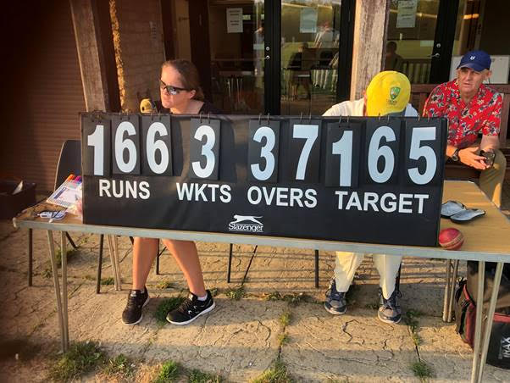
So as the leaves begin to fall, it’s time to take leave of cricket.
To hibernate in local hostelries, and in alternate sports.
To retreat to warmer climes and to reflect on times.
Of spilled catches and unequal matches.
When we scored a few runs, while Shaws scored tons.
When we bagged rabbits and chased leather.
Until we do it all again, together.
On the South Lawn.
With the eagerly awaited dawn of next season.
Report: Malcolm Percy Bysshe fucking Wordsworth West

